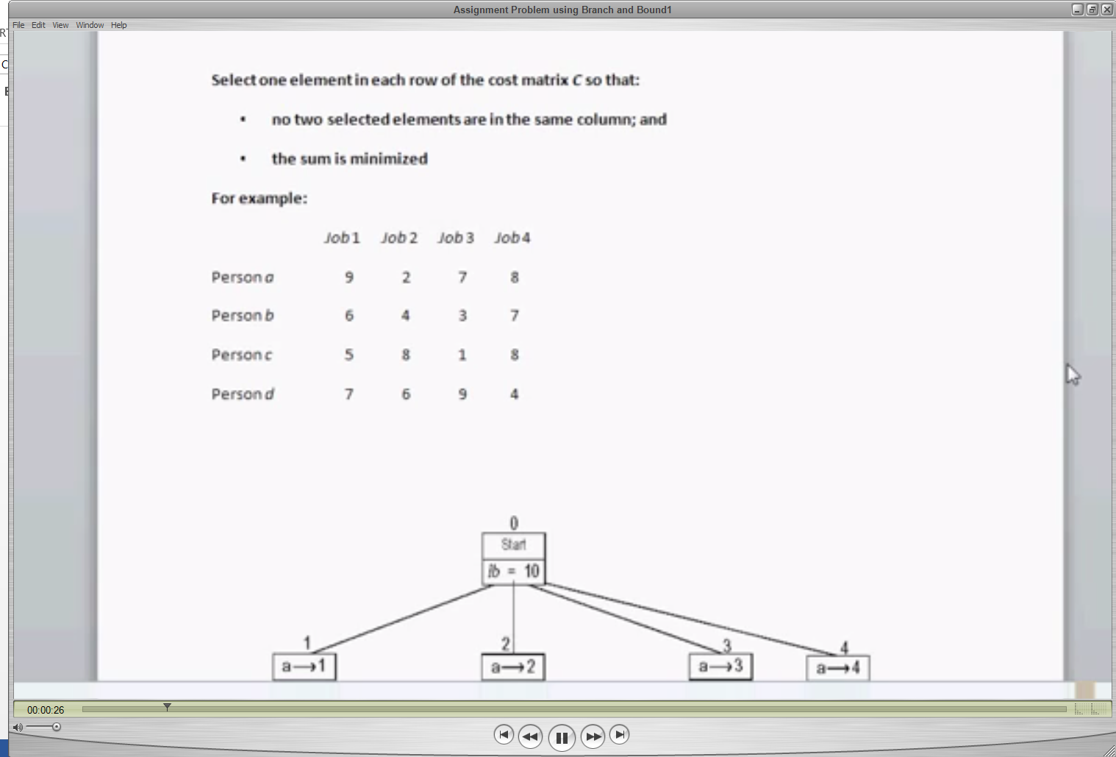

Person a does Job1 at 9 and so on.

The lowest cost at which a,b,c,d do a Job is 2+3+1+4= 10

So start lb = 10. That is root.

Say you assign Job 1 to a. Cost is 9. You cannot assign Job1 to anyone else.

For Person b look at the lowest cost out of 4,3,7 i.e. 3

For Person c, look at the lowest cost out of 8,1,8 i.e. 1

For Person d, look at the lowest cost out of 6,9,4. i.e. 4.

9 + 3 + 1+ 4 = 17. So lb = 17.

Say you assign Job 2 to a. Cost is 2. You cannot assign Job 2 to anyone else.

For Person b, look at the lowest cost out of 6,3,7 i.e.3

For Person c, look at the lowest cost out of 5,1,8 i.e. 1

For Person d, look at the lowest cost out of 7,9,4 i.e. 3.

2+3+1+4 =10. So lb=10.

Say you assign Job 3 to a. Cost is 7. You cannot assign Job 3 to anyone else.

For Person b, look at the lowest cost out of 6,4,7 i.e 4

For Person c, look at the lowest cost out of 5,8,8 i.e 5

For Person d, look at the lowest cost out of 7,6,4 i.e 4.

7+4+5+1+4 =13. So lb = 20

Say you assign Job 4 to a. Cost is 8. You cannot assign Job 4 to anyone else.

For Person b look at the lowest cost out of 6,4,3 i.e 3

For Person c look at the lowest cost out of 5,8,1 i.e 1

For Person d look at the lowest cost out of 7,6,9 i.e 6.

8+3+1+6 =18. So lb = 18

A=2 gives you least cost. So we decide that Job2 be given to A.

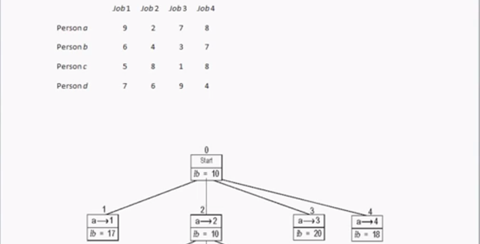

Now, you have to select Job for Person B,C and D.

Job 2 is already assigned to A. So, A and Job 2 cannot be considered.

Say you assign Job 1 to b. Cost is 6. You cannot assign Job1 to anyone else.

For Person c, look at the lowest cost out of 1,8 i.e. 1

For Person d, look at the lowest cost out of 9,4 i.e. 4.

2+6+1+4 = 13 (We consider 2 as Job 2 is already assigned to A)

Say you assign Job 3 to b. Cost is 3. You cannot assign Job3 to anyone else.

For Person c, look at the lowest cost out of 5,8 i.e. 5

For Person d, look at the lowest cost out of 7,4 i.e. 4.

2+3+5+4 = 14 (We consider 2 as Job 2 is already assigned to A)

Say you assign Job 4 to b. Cost is 7. You cannot assign Job4 to anyone else.

For Person c, look at the lowest cost out of 5,1 i.e. 1

For Person d, look at the lowest cost out of 7,9 i.e. 7.

2+7+1+7 = 17 (We consider 2 as Job 2 is already assigned to A)

B=1 gives you least cost. So we decide that Job1 be given to B.

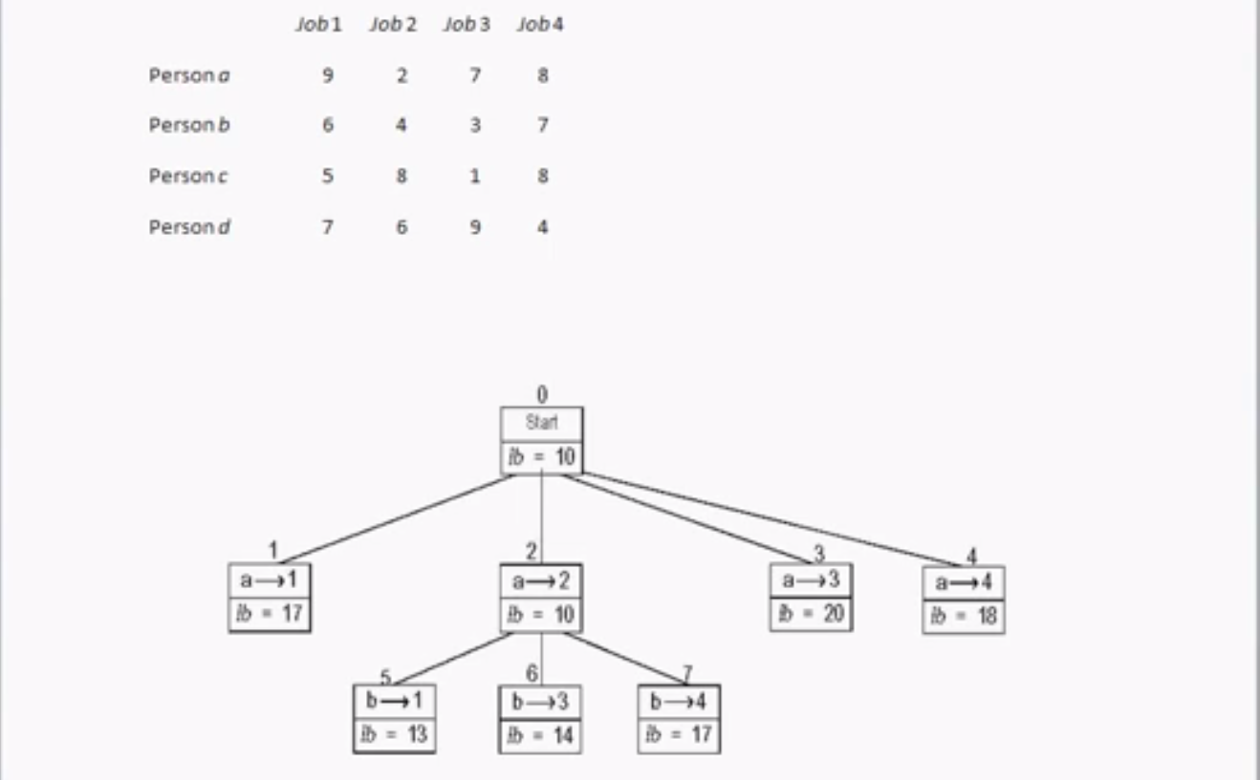

Similarly, we continue for the remaining jobs.